**GOVERNMENT COLLEGE OF TECHNOLOGY**

**COIMBATORE-13**

**WANDERLUST : A PERSONALIZED TRAVEL PLANNING AND TRACKING APP**

An Android Application Using Kotlin

**Submitted By..**

Bhavadharini S - 71772218106

Harinee S - 71772218113

Sree Varshini K - 71772218147

Theetchanyadevi K - 71772218154

**1.INTRODUCTION:**

Wanderlust is a cutting-edge travel planning and tracking app designed to cater to wanderers, adventurers, and meticulous planners alike. Whether you're an experienced traveler or someone exploring the joys of travel for the first time, Wanderlust simplifies every aspect of your journey. From organizing itineraries and booking accommodations to tracking your trips and creating memorable travel journals, Wanderlust is your ultimate travel companion.

**Purpose and Features**

* **Comprehensive Travel Planning**: Create detailed itineraries with integrated maps, transportation options, and real-time weather updates.
* **Budget Management**: Set travel budgets, track expenses, and receive recommendations to stay within your limits.
* **Trip Tracking**: Keep track of past and current trips with detailed logs and travel stats.
* **Community and Recommendations**: Connect with fellow travelers, share your experiences, and discover hidden gems based on personalized suggestions.
* **Interactive Travel Journal**: Document your adventures with photos, notes, and location tags, creating a digital scrapbook you can cherish forever.
* **Notifications and Reminders**: Get timely alerts for upcoming flights, hotel check-ins, and itinerary updates.
* **Offline Access**: Enjoy offline support for essential features like maps, itineraries, and local travel tips.

**Why Wanderlust?**

* **User-Centric Design**: Intuitive, sleek, and visually appealing interface for effortless navigation.
* **Personalization**: Tailored recommendations based on your preferences, travel history, and interests.
* **Collaborative Planning**: Invite friends or family to collaborate on itineraries and share travel expenses.
* **Sustainability Goals**: Features eco-friendly travel tips and options to minimize your environmental footprint.

**Benefits**

* Simplify complex travel arrangements and focus on enjoying your journey.
* Stay organized with all travel details consolidated in one place.
* Relive your experiences through an interactive and shareable travel journal.
* Foster a global community of like-minded travelers and discover unique destinations.

**Future Enhancements**

* Integration with AR/VR for virtual pre-trip explorations.
* AI-driven recommendations for optimized travel experiences.
* Loyalty program trackers and rewards management.
* Multilingual support for international accessibility.

1. **LITERATURE SURVEY**

*Existing problem:*

Traveling can be an exciting yet overwhelming experience due to several challenges:

1. **Fragmented Planning**: Travelers often rely on multiple platforms for booking flights, accommodations, and planning itineraries, leading to scattered information and confusion.
2. **Expense Management**: Managing travel budgets and tracking expenses while on the go can be difficult and time-consuming.
3. **Lack of Personalization**: Existing tools provide generic recommendations, often failing to align with individual preferences or interests.
4. **Disorganization During Travel**: Maintaining essential details like tickets, reservations, and itineraries can be chaotic, especially during multi-destination trips.
5. **Missed Opportunities**: Travelers may overlook unique local experiences or activities due to a lack of centralized, curated recommendations.
6. **Limited Offline Access**: Many apps fail to provide offline functionality, making them unreliable in remote areas with poor connectivity.

*Proposed solution:*

Wanderlust addresses these issues with an all-in-one travel planning and tracking platform:

1. **Unified Travel Hub**: Combines itinerary creation, booking integrations, and real-time updates in one app to streamline planning and execution.
2. **Budget Management Tools**: Features easy-to-use trackers to set, monitor, and optimize expenses, ensuring financial control during the trip.
3. **AI-Powered Personalization**: Delivers tailored recommendations based on user preferences, travel history, and location-specific insights.
4. **Travel Organization Made Simple**: Centralizes all travel documents, tickets, and itineraries, ensuring quick and hassle-free access.
5. **Community-Driven Discoveries**: Enables travelers to connect, share experiences, and explore curated activities recommended by like-minded adventurers.
6. **Offline Support**: Offers offline access for essential features like maps, saved itineraries, and local tips, ensuring reliability even without connectivity.

**3.Hardware Requirements of the Project:**

**Minimum Requirements:**

**Operating System:**

* + - 1. Android: Android 8.0 (Oreo) or higher.
      2. iOS: iOS 12 or higher.

**Processor:**

1.Quad-Core 1.4 GHz or equivalent.

**Memory (RAM):**

**1.**2 GB.

**Storage Space:**

1.100 MB for app installation.

2.Additional 1 GB for offline maps and saved data.

**Display:**

1. Screen resolution of 720 x 1280 pixels (HD).

**Network:**

Wi-Fi or cellular connectivity for online features.

**Development Hardware (For Developers):**

**Operating System:**

Windows 10/11, macOS Monterey, or Linux (Ubuntu 20+).

**Processor:**

Intel Core i5/i7 or AMD Ryzen 5/7.

**RAM:**

8 GB (Minimum), 16 GB (Recommended).

**Storage Space:**

SSD with at least 256 GB free for development tools and emulators.

**Development Tools:**

1. Android Studio, Xcode, or equivalent IDEs.
2. Emulators for device testing (e.g., Android Emulator, iOS Simulator).

**Connectivity:**

Stable internet for testing real-time updates and APIs.

**4.FLOWCHART :**

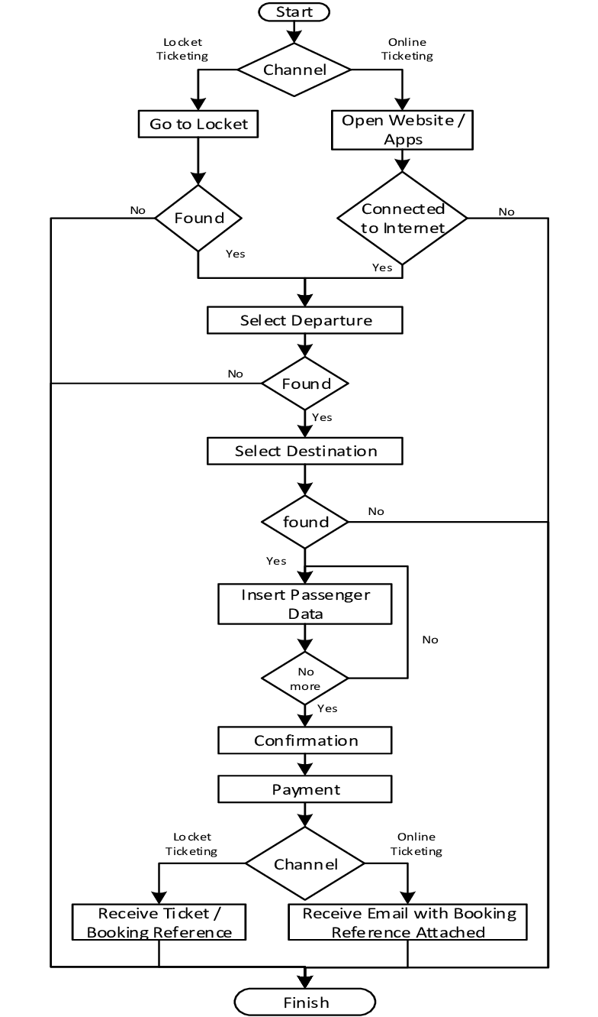

1. **RESULT:**

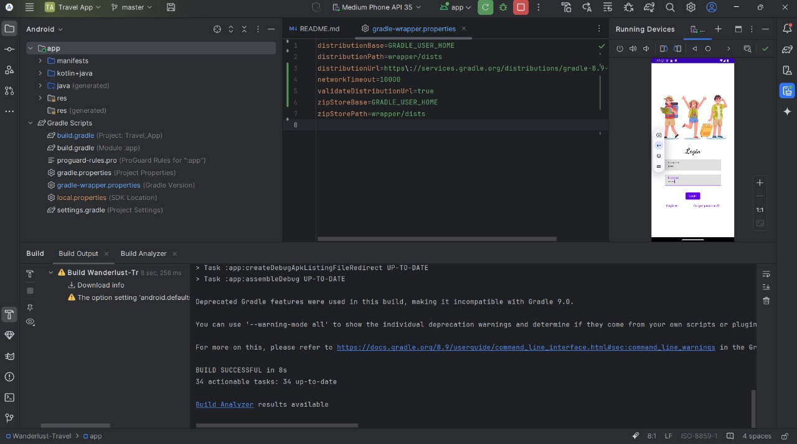

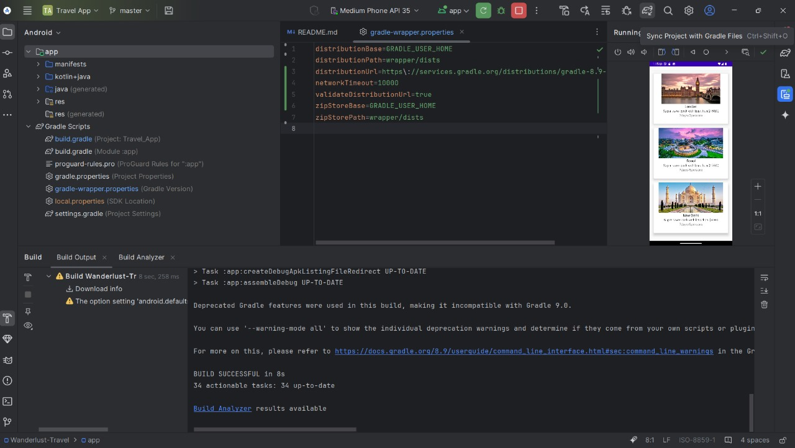

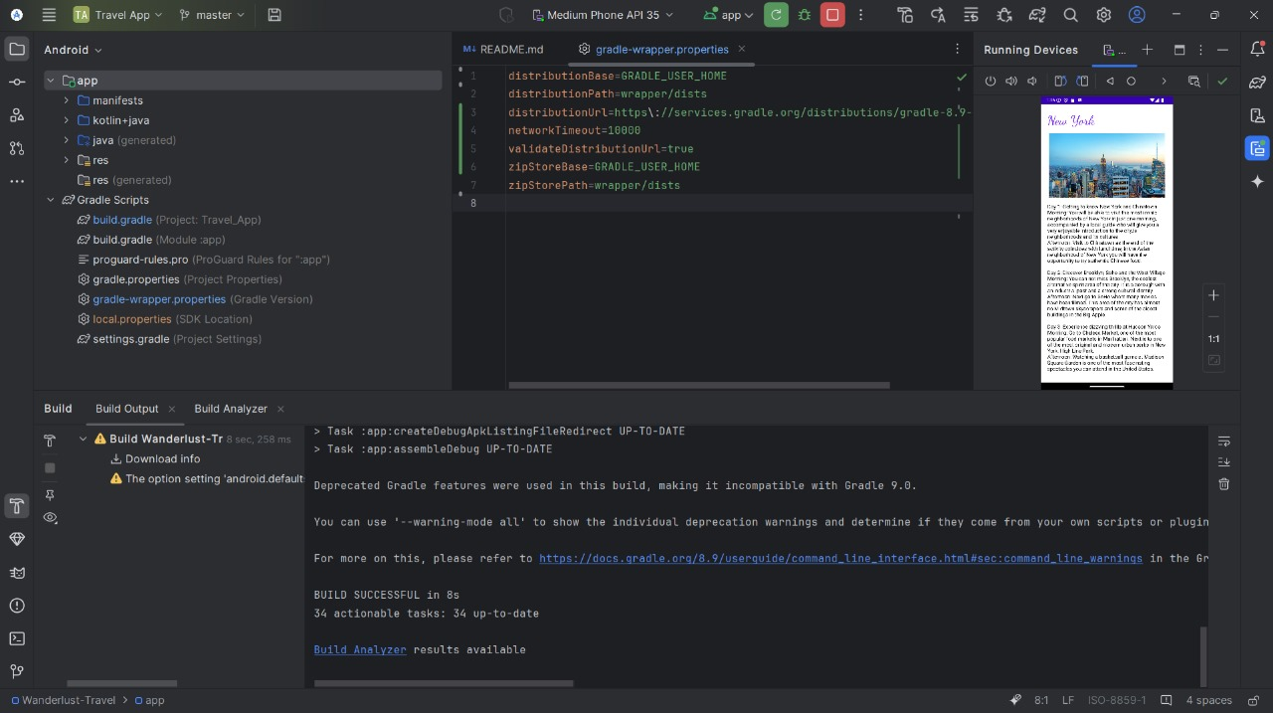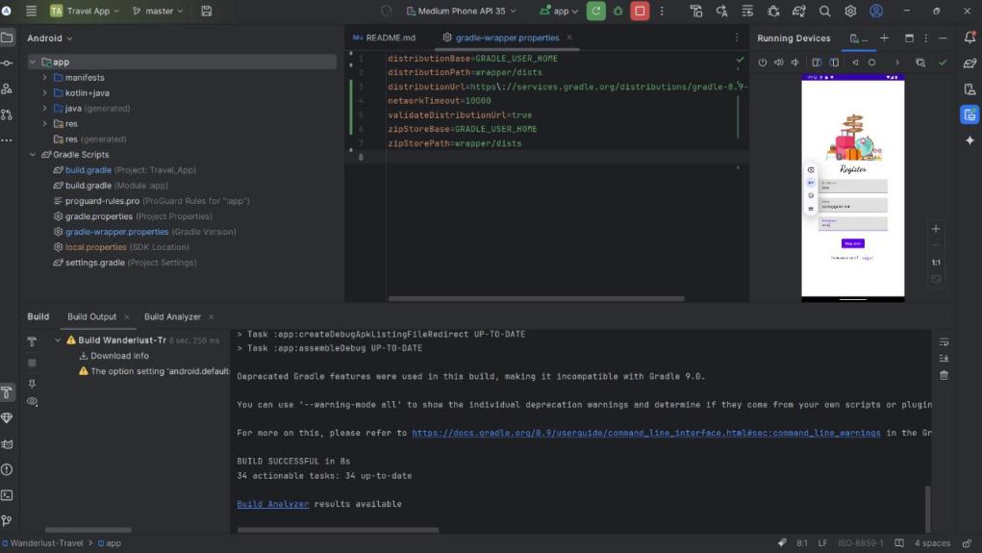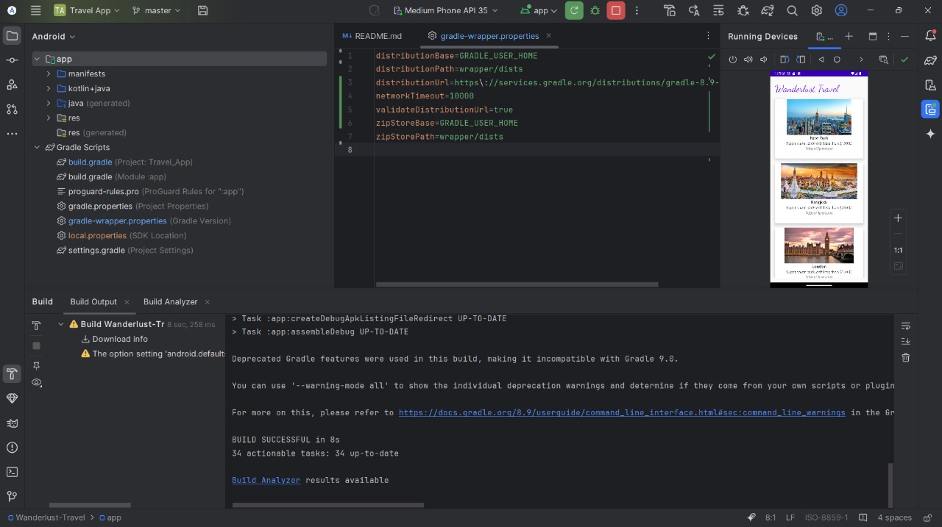

**6.Application:**

**Personal Travel Management**

* · Organize and plan vacations, business trips, and weekend getaways efficiently.
* Track itineraries, expenses, and memories in one place.

· **Group Travel Coordination**

* · Enable collaborative itinerary planning with friends, family, or colleagues.
* Share budgets and track group expenses seamlessly.

· **Tourism and Hospitality Industry**

* · Provide a platform for travel agencies to recommend packages and activities.
* Collaborate with hotels, airlines, and tour operators for integrated bookings.

· **Local Exploration**

* · Help users discover hidden gems and local attractions with personalized recommendations.
* Support offline exploration with maps and tips for remote locations.

· **Educational and Cultural Tourism**

* · Assist users in creating custom itineraries focused on cultural and educational experiences.
* Promote eco-tourism and sustainable travel practices.

· **Content Creation**

* · Allow bloggers and influencers to document and share their journeys.
* Provide a centralized platform to manage travel journals and media.

· **Event Coordination**

* · Aid in planning travel and accommodations for conferences, weddings, and festivals.

1. **Conclusion:**

Wanderlust redefines the travel experience by offering an all-in-one solution that simplifies planning, tracking, and sharing adventures. Its user-centric design and intelligent features empower travelers to focus on exploring rather than managing logistics.

By addressing common challenges like fragmented planning and lack of personalization, Wanderlust bridges the gap between traditional travel methods and modern convenience. The app not only ensures seamless journeys but also fosters a sense of community by enabling users to share experiences and insights.

Whether for personal getaways or professional trips, Wanderlust is the ideal companion for anyone seeking to make travel memorable, efficient, and enjoyable. With potential for integration with emerging technologies and a commitment to sustainability, Wanderlust is poised to be a game-changer in the travel industry.